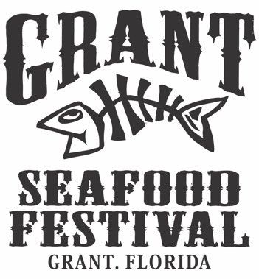

The 57th annual Grant Seafood Festival will be held Saturday, March 2nd, 2024, 9am – 7pm, and Sunday, March 3rd, 2024, 9am – 5pm. Our event features food, live music, and arts & crafts held on the festival grounds located behind the Grant Community Club at 4580 1st Street in Grant, Florida. The festival could only be possible through the generosity of our hundreds of volunteers. All proceeds go back into the community to support college scholarships, the Grant Library and Grant Historical (Benson) House. No parking fee or admission fee is charged and in past years over 45,000 people from all over the world have attended our festival.

General Information and Event Rules

Participation
If you would like to be a part of our festival, please provide pictures of your hand-made or unique and creative items, along with a completed application, and a self-addressed, stamped envelope to:

Victoria Holmes
2134 Capital Drive SE
Palm Bay, FL 32909

Applications are accepted until all spaces are full and/or there is time to process the application. Returning crafters must have their applications postmarked no later than November 15, 2023, to be able to reserve the same space as the prior year(s) or to request a particular space. Spaces ARE NOT guaranteed, but we always do what we can to accommodate. Acceptance letters will be sent by mid-December.

Each exhibitor is responsible for collecting Brevard County Florida’s 7% sales tax.

If credit card information is provided on application, you will be charged at time of receipt/acceptance and a copy of your receipt will be mailed out with your approval letter. NO refunds will be issued in the event you cancel.

Acceptance
All crafts entered for exhibit may be either, handcrafted or unique and creative items or other manufactured products/goods at the discretion of the event organizer. No selling of fresh food items, however, pre-packaged jars and packages will be taken under consideration on an individual basis and acceptance lies solely with the event organizer. Should you have a food product that is accepted for participation you must submit a current Agricultural Food Certificate which must be viewable by the public at all times. All items to be sold must be listed on the application and you must include pictures of ALL items to be sold.

The Grant Community Club reserves the right to accept or reject any application for any reason.

There will be a $100.00 fee for any returned check.

Booths and Fees
Booth fees, including sales tax, are $250.00. Payment must be received by February 1st, 2024, or the booth will be forfeited.

Display areas are 10 x 10 areas in grassy, sandy soil. No electrical hook ups are provided or available however small, quiet generators are allowed only with prior notification and approval. There is no water hookup either. You should be prepared for sun, wind, or rain. Please make sure you have weights for your tent(s) as the show will go on rain or shine.

No oversized or unmanageable exhibits are allowed, and you must stay within your reserved space, including back stock. You agree to make any adjustments to your space when requested to do so by the event organizer. Booths must be up, in their entirety, for the duration of the festival and be attended at all times. NO pets are allowed, and children must be attended to at all times. Exhibitors are required to clean up their reserved space before departing on Sunday evening.

Insurance
You must provide a current certificate of Special Event Liability Insurance covering you and your booth for the dates of the festival. The Certificate Holder section must read, “Grant Community Club, Inc., 4580 1st Street, Grant, Florida 32949” and same must be listed as Additional Insured. Minimum coverage limits must be $1,000,000.00. If you need to purchase insurance these are companies we recommend, TheEventhelper.com or KandKInsurance.com. Certificates of Insurance must be received no later than February 1st, 2024, or the booth will be forfeited.

Parking
There are no parking fees for crafters or attendees. Upon check-in you will be given a parking pass and directed to crafter parking. The parking pass must be displayed on your windshield, and it will include your booth number. There is to be NO parking behind your exhibit and NO overnight parking is allowed on the festival grounds.

Event Set-Up
Event set up times are Friday, March 1st from 10am – 6pm and Saturday morning, March 2nd from 6:30am – 8am. You must check in no later than 8am Saturday. You will receive your booth assignment upon check in at the crafter information booth which is located on the west side of the festival grounds near the playground.

